The Blind Bowler

American Blind Bowling Association

January 2024

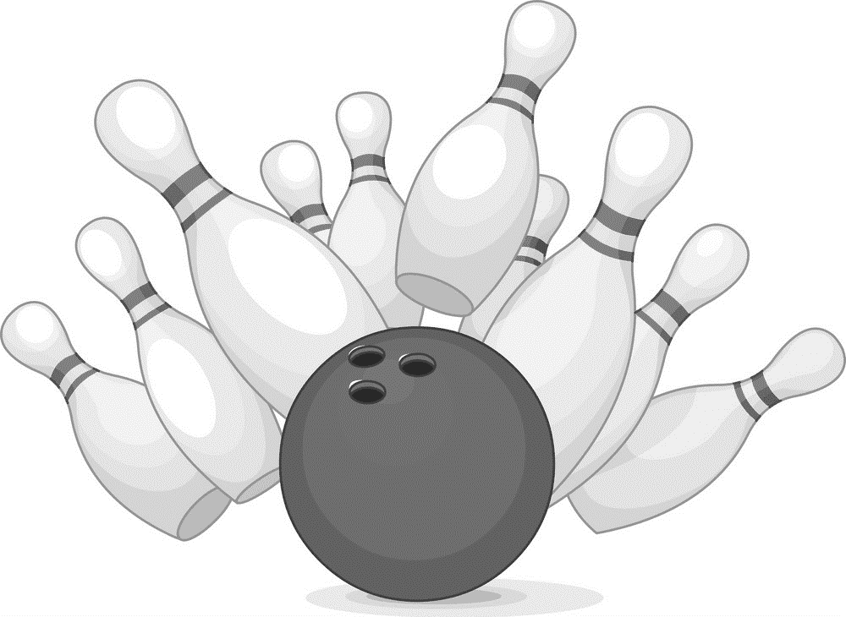

ABBA1951.com

The Blind Bowler
American Blind Bowling Association
January 2024

- ABBA 2023 – 2024 OFFICERS 1
- FROM THE 1st VICE PRESIDENT 2
- FROM THE DESK OFABBA SECRETARY TREASURER . 3
- FROM THE NATIONAL TOURNAMENT COMMITTEE 8
- MBBA TOURNAMENT 9

ABBA 2023 – 2024 OFFICERS

President
Charles Glaser
Stone Mt., GA
678-521-2976
cglaser2@gmail.com

1st Vice President
Tanya Jones
Winston-Salem, NC
336-817-6138
tatarenee1@gmail.com

2nd Vice President
Daniel Hope
Tulsa, OK
919-986-7287
m0b1us0099@gmail.com

Secretary/Treasurer
Rozella Campbell
2829 Tall Oaks Ct., Apt. 11
Auburn Hills, MI 48326
248-410-2411
rozellacampbell2826@gmail.com

Tournament Director
Sandy McDaniel
115 Powell Blvd., Apt. 14102
Daytona Beach, FL 32114
386-576-6413
sandymcdan01@yahoo.com

FROM THE 1st VICE PRESIDENT

Hi fellow bowlers,

I hope you had a great time with friends and family during the holidays!

The finance committee is meeting quarterly to review expenses. At the mid-year meeting, Wilbert Turner reminded everyone of our ongoing candy and nut sale with Terri Lynn (https://americanblindbowling.terrilynn.com). He mentioned that if your order was over $30, then regular shipping was included 😀

-Tanya Jones
1st Vice-President

FROM THE DESK OF
ABBA SECRETARY TREASURER
January 2024

Please remember members who said good-by to family, friends and team members, all who are no longer with us. Please remember our member who had surgery and may not be with us in May. Keep Mike Staab in your thoughts and, if possible, send encouraging “Get Well’s” and “Miss You’s”, etc. Fred Nickl has chosen not to continue bowling because of health reasons. Fred also needs to hear from you with words of encouragement. Last but not least, John (Big John) Mavis, recently had a fall, hit his head on the oven, was taken to the hospital by his caregiver Robert Kenz. Robert states Big John’s injuries seemingly are serious, will keep you informed. For those of you who have the time, remember our members who are not doing well, send a card, make a phone call to let them know they are not forgotten. They put in a lot of years with ABBA, and we need to show our appreciation. “GIVE THEM THEIR FLOWERS WHILE THEY CAN SMELL THEM.”

Congratulations once again to our Tournament Chair Roderick Wilson and wonder woman Sandy McDaniel on a successful Mid-Year meeting. They made it work without having all of the pieces being in place. A SHOUT OUT TO: those members who stepped up to the plate to help on those committees where needed, SHARON BENTON, who will make sure things not in place in November, will be in May. PAST PRESIDENT MINTZ, who will make sure the secretary treasurer will have a decent way to record the meeting in May. 2nd VICE PRESIDENT WILSON for staying on top of things that some miss, speaking out when others remain silent. PAST PRESIDENT TURNER, for his efforts to improve the structure and members of the finance committee.

CONTINUING TO ASK ANY LEAGUE, OR MEMBERS WITH USED GUIDERAILS THAT YOU ARE WILLING TO DONATE OR SELL, PLEASE CONTACT THE SECRETARY ASAP, AT: 248-410-2411 or rozellacampbell2826@gmail.com
Many are trying to start new leagues or need rails to be a part of the recreational programs.

Reasons to be happy!!!!!!
- We are happy to announce we have 25 leagues that have sanctioned thus far this year compared to last year (26).

- Awards this period: (reminder, you cannot receive two awards during the same game you must choose one).

60 PLUS
- Omarion Allen – SM – average -71 – bowled – 143 – Gate City – Greensboro, NC
- Sam Mantel – PM – average – 81 – bowled – 141 – CBBL – Cincinnati, Ohio

75 OVER
- Sandra Anderson – SF – average – 129 – bowled – 213 – GCBB – Cleveland, Ohio
- D’Peaches Dinkins – SF – average – 129 – bowled – 213 – GCBB – Cleveland, O
- Noah Neff – SM – average – 154 – bowled – 238 – CBBL – CBBL – Cincinnati, Ohio
- David Bragassa – PM – average – 162 – bowled – 38 – CBBL – Cincinnati, Ohio

100 OVER
- Matthew Donley – SM – average – 185 – bowled – 289 – CBBA – Col.

SILVER
- Jim Koo – PM – average – 149 – bowled – 235 – CBBL – Cincinnati, Ohio
- Christine Menges – TF – average – 100 – bowled – 155 – CBBA – Col.
- Matthew Donley – SM – average – 185 – bowled – 289 – CBBA – Col.

BRONZE
- David Bragassa – PM – average – 163 – bowled – 215 – CBBL– Cincinnati, Ohio

SPLIT CONVERSION
- David Koo – SM – average – 151 – bowled – 179 – split 8 – 10 – CBBL – Cincinnati, Ohio
- Shantel Peebles – SF – NA – split 8 – 10 – St Louis Railroaders

TRIPLICATE CHEVRON
- Steve Feldman – TM – average – 97 – triplicate score – 87 / 87 / 87 – CBBL – Cincinnati, Ohio

Some tidbits from the Mid-Year:
- Hopefully everyone is looking forward to being at the May convention and enjoying Reno, tidbits from November Mid-Year attendees: Take plenty of snacks if you are a muncher, including your favorite brand of K-Cup coffee and a large coffee and water container, a sweater if you become chilly in the air condition, comfortable shoes, walking from (although in the same building, the three casinos, lots of walking. We did have a problem with gnats, hopefully that will be resolved in May and closed restaurants will be open. I am sure some who attended Mid-Year have some tidbits they will be able to add in the last issue of the Blind Bowler that will be helpful to those attending in May.
- Now we look forward to another good time in May at the convention in Reno and then preparing Cleveland Ohio

-Rozella Amerson Campbell
ABBA Secretary Treasurer

FROM THE NATIONAL TOURNAMENT COMMITTEE

The tournament committee met during the mid-year meetings in Reno to work out preparations for our upcoming event in May. We discussed things to do to assist our bowlers as they travel around the hotel, since it is so big, such as volunteers at key places like the lobby, elevators, escalators, etc.

We also spoke with the hotel sales representative, who answered several of our questions and concerns. He assured us that he would follow up on them and get back with us.

We discussed potential locations for future events. More to come, so stay tuned.

In our next newsletter, we will provide a list of attractions which we can visit in Reno as well as hotel booking and airport information.

We are looking forward to seeing everyone in Reno.

-Rod Wilson,
National Tournament Committee Chair

MBBA TOURNAMENT

Attention all MBBA bowlers,

This is your official invitation to get ready for a fun filled time here in Milwaukee Wisconsin. The Milwaukee Beer Barrels league and The Rock County Railers league from Janesville Wisconsin, cordially invite all MBBA bowlers and guests to attend our tournament to be held on March 15th, 16th, and 17th 2024. The Four Points by Sheridan Hotel is close to Mitchell International Airport. There is a good selection of restaurants within a 2-mile radius of the hotel. The hotel shuttle will be available to take anyone to restaurants within a 1-mile radius. If gambling is your thing, Potowatomi casino is only a short Uber ride away. When booking your hotel room, you must let them know how many people will be staying in the room. Each person will get 1 half-price breakfast voucher for each day. The hotel does have a bar, restaurant, and a swimming pool. Room rates are $114 per night plus tax for a standard room. Below, you will find the name, address, and phone number of the hotel:

Four Points by Sheraton Milwaukee Airport
5311 S. Howell Avenue
Milwaukee, WI 53207
888-735-0714
https://www.marriott.com/event-reservations/reservation-link.mi?id=1698425604106&key=GRP&app=resvlink

We will be bowling at the recently renovated Bowlero Lanes which has 72 alleys, two bars and great food. Below is the information for the bowling alley:

Bowlero lanes
11737 W. Burleigh Street
Wauwatosa, Wi 53222

There will be many opportunities to win cash and nice prizes throughout the tournament.

HOPE TO SEE YOU THERE!

-Jeff Spantikow
Host Committee Chairman

ABBA
2440 Banning Road
Cincinnati, OH 45239

